Home tasks for discipline
“Waste managemen”

Home task 1 (HT)
History of waste management
Throughout most of history, the amount of waste generated by humans was insignificant due to low levels of population density and exploitation of natural resources. Common waste produced during pre-modern times was mainly ashes and human biodegradable waste, and these were released back into the ground locally, with minimum environmental impact.
Tools made out of wood or metal were generally reused or passed down through the generations.
However, some civilizations have been more profligate in their waste output than others. I
n particular, the Maya of Central America had a fixed monthly ritual, in which the people of the village would gather together and burn their rubbish in large dumps.

Modern era

Home task 2
Collection, transport, treatment and disposal of waste, together with monitoring and regulation of the waste management process and
Waste-related laws, technologies, economic mechanisms.
Differences of Waste management practices are not uniform among countries (developed and developing nations); regions (urban and rural areas), and residential and industrial sectors can all take different approaches.

Home task 3
Classification of Waste
Hazardous Industrial Waste. Hazardous Substances
(Classification, Packaging and Labeling)
Construction & Demolition Waste
Non-Hazardous Waste.

Home task 4
Municipal Solid Waste
Type Components of
Waste
Process
Incineration
Gasification
Merits
Concept of Integrated Solid Waste Management
Plastic Recycling
Mechanical Recycling Process

Home task 5

Solid Waste Management System

Refuse Incineration Routes with Energy Recovery

Pyrolysis of Refuse

Biodegradation Processes

Biodegradation of Refuse

Composting

Windrow compositing

Aerated static pile composting

In-vessel composting:

Vermicomposting

Anaerobic Digestion

Home task 6. Waste management by region

Kazakhstan

Russia

China]
Municipal solid waste generation shows spatiotemporal variation. In spatial distribution, the point sources in eastern coastal regions are quite different. Guangdong, Shanghai and Tianjin produced MSW of 30.35, 7.85 and 2.95 Mt, respectively. In temporal distribution, during 2009–2018, Fujian province showed 123% increase in MSW generation while Liaoning province showed only 7% increase, whereas Shanghai special zone had a decline of −11% after 2013. MSW composition characteristics is complicated. The major components such as kitchen waste, paper and rubber & plastics in different eastern coastal cities have fluctuation in the range of 52.8–65.3%, 3.5–11.9%, and 9.9–19.1%, respectively. Treatment rate of consumption waste is up to 99% with a sum of 52% landfill, 45% incineration, and 3% composting technologies, indicating that landfill still dominates MSW treatment.

Morocco
Morocco has seen benefits from implementing a $300 million sanitary landfill system. While it might appear to be a costly investment, the country's government predicts that it has saved them another $440 million in damages, or consequences of failing to dispose of waste properly.

San Francisc
San Francisco started to make changes to their waste management policies in 2009 with the expectation to be zero waste by 2030.^{[89]} Council made changes such as making recycling and composting a mandatory practice for businesses and individuals, banning Styrofoam and plastic bags, putting charges on paper bags, and increasing garbage collection rates. Businesses are fiscally rewarded for correct disposal of recycling and composting and taxed for incorrect disposal. Besides these policies, the waste bins were manufactured in various sizes. The compost bin is the largest, the recycling bin is second, and the garbage bin is the smallest. This encourages individuals to sort their waste thoughtfully in respect to the sizes. These systems are working because they were able to divert 80% of waste from the landfill, which is the highest rate of any major U.S. city. Despite all these changes, Debbie Raphael, director of the San Francisco Department of the Environment, states that zero waste is still not achievable until all products are designed differently to be able to be recycled or compostable.

Turkey
TTurkey generates 28,858,880 tons of solid municipal waste per year; the annual amount of waste generated per capita amounts to 390 kilograms. According to Waste Atlas, Turkey's waste collection coverage rate is 77%, whereas its unsound waste disposal rate is 69%. While the country has a strong legal framework in terms of laying down common provisions for waste management, the implementation process has been considered slow since the beginning of 1990s.

United Kingdom

Waste management policy in England is a responsibility of the Department of the Environment, Food and Rural Affairs (DEFRA). In England, the "Waste management plan for England" presents a compilation of waste management policies. In the devolved nations such as Scotland Waste management policy is a responsibility of their own respective departments.

E-waste]
A record 53.6 million metric tonnes (Mt) of electronic waste was generated worldwide in 2019, up 21 per cent in just five years, according to the UN’s Global E-waste Monitor 2020, released today. The new report also predicts global e-waste – discarded products with a battery or plug – will reach 74 Mt by 2030, almost a doubling of e-waste in just 16 years. This makes e-waste the world’s fastest-growing domestic waste stream, fueled mainly by higher consumption rates of electric and electronic equipment, short life cycles, and few options for repair. Only 17.4 per cent of 2019’s e-waste was collected and recycled. This means that gold, silver, copper, platinum and other high-value, recoverable materials conservatively valued at US $57 billion – a sum greater than the Gross Domestic Product of most countries – were mostly dumped or burned rather than being collected for treatment and reuse.^{[95]}

Home task 8

Conventional Digestion

RefCom process

WMC process

Waste biogas process

Dry Anaerobic Digestion Process

Water Stabilisation Pond System

Waste biogas process

Dry Anaerobic Digestion Process

Two-phase Digestion

Home task 9
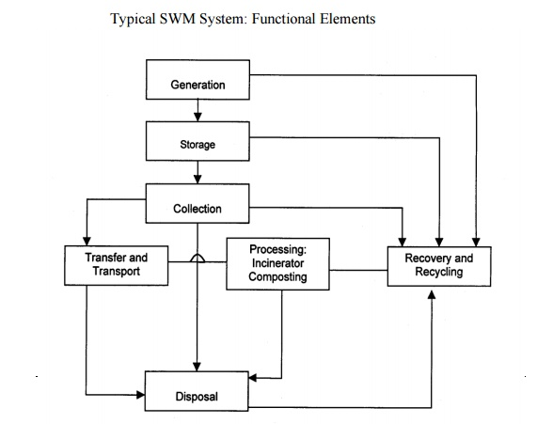
Solid Waste Management System

A SWM system refers to a combination of various functional elements associated with the management of solid wastes. The system, when put in place, facilitates the collection and disposal of solid wastes in the community at minimal costs, while preserving public health and ensuring little or minimal adverse impact on the environment. The functional elements that constitute the system are:

(i) Waste generation: Wastes are generated at the start of any process, and thereafter, at every stage as raw materials are converted into goods for consumption. For example, wastes are generated from households, commercial areas, industries, institutions, street cleaning and other municipal services. The most important aspect of this part of the SWM system is the identification of waste.

(ii) Waste storage: Storage is a key functional element because collection of wastes never takes place at the source or at the time of their generation. The heterogeneous wastes generated in residential areas must be removed within 8 days due to shortage of storage space and presence of biodegradable material. Onsite storage is of primary importance due to aesthetic consideration, public health and economics involved. Some of the options for storage are plastic containers, conventional dustbins (of households), used oil drums, large storage bins (for institutions and commercial areas or servicing depots), etc.

Home task 10

Sewage and Sludge
Waste Stabilisation Pond Systems (WSPS)
Water Stabilisation Pond System Category Technology
Duckweed Pond System (DPS) Duckweed Pond Systems Advantages Disadvantages
Facultative Aerated Lagoon
Activated Sludge Treatment
Hazardous Waste & Industrial Waste Water
Sludge Treatment

Home task 11

Facultative Aerated Lagoon Activated Sludge Treatment
BIOFOR (Biological, Filtration & Oxygenated
Reactor)
Technology BIOFOR Technology Advantages Disadvantages
Collection and Transportation
Recycling and Reuse
The three types of available recycling plants are: Mobile, Semi-Mobile and Stationary Plant

